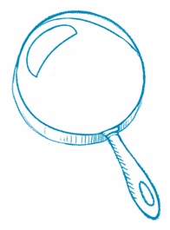
Read Between the Lines
Make an Inference When you make an inference, you go beyond
the author’s words to understand what is not directly said in the text.
Article Title
Inference
What is an idea you gathered from the article that is not directly
stated in the text?
Text Evidence
Which sentences or details support your thinking?
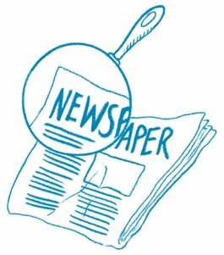
What’s It About?
Main Idea What is this article mostly about? Write the main idea of the article. Then, write three details that support the main idea.
Article Title
Main Idea

Detail

Detail
Detail

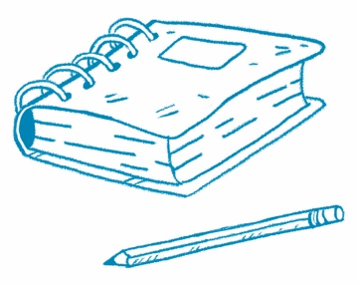
Make a Claim
Author’s Purpose Why do you think the author wrote this article? Use evidence from the text to determine the author’s purpose. To find evidence, look for facts, data, quotes, descriptions, photos, and examples.
Article Title
Make a claim. Why did the author write this article?

Evidence | Evidence
Why do you think the author chose the photo shown in the article?

State your reasoning. How does the evidence support your claim?

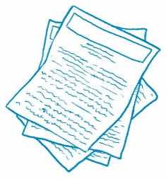
Compare Two Articles
Compare Text Find two news articles about similar topics.
Read each article. Then, answer the questions.
Article Title | Article Title
What is the main idea? | What is the main idea?
What are the key details? | What are the key details?
How are these articles similar?

In what ways are they different?

Which article did you like better? Why?

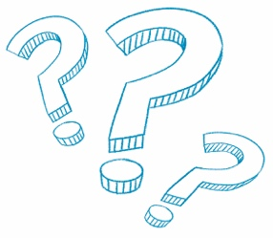
What Do You Think?
Answer the question at the end of the article.
Article Title

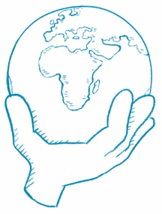
What Can You Do?
Answer the question at the end of the article.
Article Title

