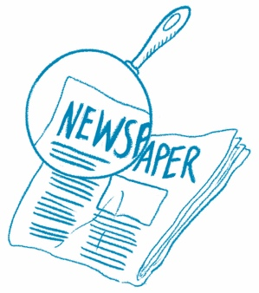
The Big Picture
Main Idea What is this article mostly about?
Draw or write the main idea. Then draw two details that support the main idea.
Article Title

Main Idea

Detail
Detail

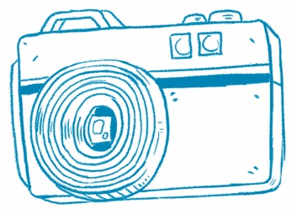
Picture This
Understanding Photos. Photos can help you understand what an article is about.

Article Title

Draw or write about one photo from the article.

Why is the photo important? Use words from the article.
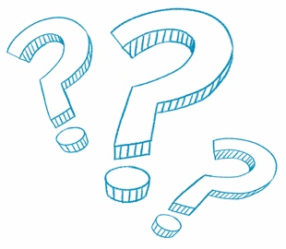
How Are They the Same?
Compare Information Find two articles about similar topics. How are they the same?
Article 1 Title | Article 2 Title
What is this article about?  Draw or write. | What is this article about?  Draw or write.
What is the same about both articles?

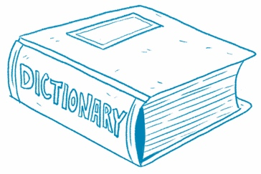
What’s That Word?
Build Vocabulary Clues from the text help you
understand new words.
Article Title

Find a bold word in the article. Write the word.

Use the word in a sentence or draw a picture.
What does the word mean? Write the definition.

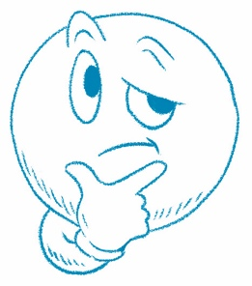
What Do You Think?
Article Title

Answer the question at the end of the article.
Draw or write.

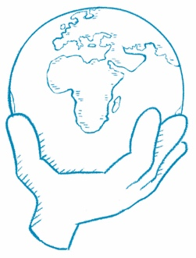
What Can You Do?
Article Title

Answer the question at the end of the article.
Draw or write.

