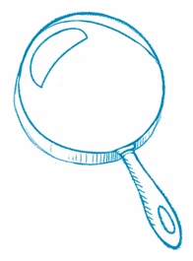
Read Between the Lines
Make an Inference When you make an inference, you go beyond
the author’s words to understand what is not directly said in the text.
Article Title Where Has All the Helium Gone?
Inference
What is an idea you gathered from the article that is not directly
stated in the text?
I think the author wants us to stop using helium in balloons.
Text Evidence
Which sentences or details support your thinking?
The author says that helium has become hard to come by. The article says that helium gas saves lives every day. MRI machines, which help diagnose many diseases, use helium. People use helium gas in balloons. The final question asks if we should prioritize how we use helium.
What’s It About?
Main Idea What is this article mostly about? Write the main idea of the article. Then, write three details that support the main idea.
Article Title Anger Erupts over Death of George Floyd
Main Idea
The unjust killing of George Floyd and other African Americans sparked peaceful protests and some violence across the United States. People called for calm and change.

Detail
Terence Floyd, George Floyd’s brother, said to “stop thinking our voice don’t matter and vote.”

Detail
Many people protested against the disregard of African American lives that they see in the United States.
Detail
On May 25, George Floyd, who was unarmed, was killed by a white police officer in Minneapolis, Minnesota.

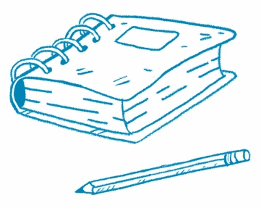
Make a Claim
Author’s Purpose Why do you think the author wrote this article? Use evidence from the text to determine the author’s purpose. To find evidence, look for facts, data, quotes, descriptions, photos, and examples.
Article Title Presidential Election Upsets
Make a claim. Why did the author write this article?
The author wanted to educate people about surprising results of past presidential elections to show that poll predications can be misleading.
Evidence  The first paragraph explains that people take polls to predict who will win, but some presidents had surprise wins. | Evidence  The article gives examples of presidential elections in which the winner was not expected to win but won by a small number of votes.
Why do you think the author chose the photo shown in the article?
I think the author chose the photo of James K. Polk because Polk’s victory is a good example of a presidential election upset.

State your reasoning. How does the evidence support your claim?
The first paragraph in an article usually tells what the article will be about. All the examples listed were about presidents who were predicted to lose but ended up winning their elections.

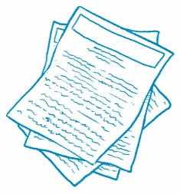
Compare Two Articles
Compare Text Find two news articles about similar topics.
Read each article. Then, answer the questions.
Article Title  What Can Lasers Do? | Article Title  The Hubble Telescope
What is the main idea?  People use lasers for many things. | What is the main idea?  The Hubble Telescope was almost a fail, but became a great success.
What are the key details?  Lasers are used in barcode scanners, DVD players, surgery, construction, and learning about objects in space. | What are the key details?  The first time the Hubble Telescope was used, the images were fuzzy. Astronauts had to go into space to fix the telescope. Images made with the Hubble Telescope have helped us learn a lot about space.
How are these articles similar?
The articles are both about a science topic. They both relate to light. They both mention how technology is used to learn about objects in space. They are about the same length.
In what ways are they different?
One article tells about a sequence of events. The other article gives examples. One of the technologies discussed detects light and the other one produces light.
Which article did you like better? Why?
I liked the article about the Hubble Telescope better because it tells an interesting and true story.
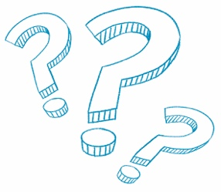
What Do You Think?
Answer the question at the end of the article.
Article Title Joe Biden Will Be the 45th President of the United States
I think it is important that each person gets a say in who the president should be because these leaders will determine laws that affect every person.
I think it is important to express our opinions. It is also important to be respectful of those with differing opinions. We should listen and try to understand their point of view. We may be surprised by their reasons and change our mind. Most importantly, we will better understand their concerns and be able to work together to find solutions that benefit all people.

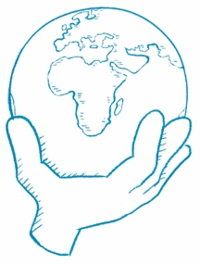
What Can You Do?
Answer the question at the end of the article.
Article Title Join the Climate Change Fight on Earth Day
There are many things I can do to help fight climate change. I can walk or ride a bike to get to places nearby. I can turn off lights when no one is in the room. I can reuse things instead of throwing them away. All of these things help reduce the amount of fossil fuel that is used. Reusing things, recycling materials, and using objects made from recycled materials also help.

