The Big Picture
Main Idea What is this article mostly about?
Draw or write the main idea. Then draw two details that support the main idea.
Article Title How to be Safe on a Bike

Main Idea
It is important to be safe when riding a bike.

Detail
Wearing a helmet keeps your head safe in case you fall.
Detail
Pay attention to cars around you and stop at stop signs.

Picture This
Understanding Photos. Photos can help you understand what an article is about.

Article Title Mask Up!

Draw or write about one photo from the article.
The second photo shows a diagram of a person wearing a mask. It shows how a cloth barrier stops viruses from spreading.

Why is the photo important? Use words from the article.
The photo shows the importance of wearing a mask to stop the spread of COVID-19.
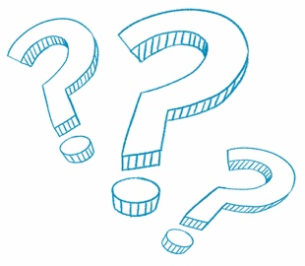
How Are They the Same?
Compare Information Find two articles about similar topics. How are they the same?
Article 1 Title  World Wildlife Day | Article 2 Title  Colorful Coral
What is this article about?  Draw or write.  This article is about wildlife that is in danger due to global warming. Coral reefs, honeybees, and orangutans are some animals that are in danger. | What is this article about?  Draw or write.  This article is about coral reefs. Coral reefs are in danger from climate change. Scientists are working to protect coral reefs and the animals that live there.
What is the same about both articles?
Climate change has caused wildlife to be at risk. People need to help protect wildlife.

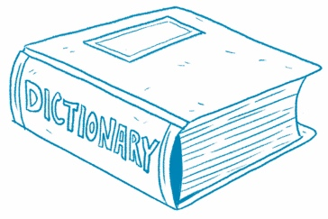
What’s That Word?
Build Vocabulary Clues from the text help you
understand new words.
Article Title What Causes It to Happen?

Find a bold word in the article. Write the word.
cause

Use the word in a sentence or draw a picture.
The alarm caused me to wake up.
What does the word mean? Write the definition.
A cause is an event or action that makes something happen.

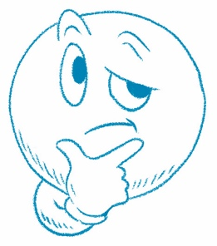
What Do You Think?
Article Title What Lives Here?

Answer the question at the end of the article.
Draw or write.
Kelp is important because it provides food for fish. Some fish hide in a kelp forest to stay safe. The kelp provides protection.

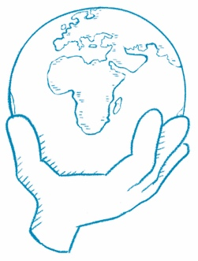
What Can You Do?
Article Title Restaurants Get Creative for Outdoor Dining in Winter

Answer the question at the end of the article.
Draw or write.
I would put small tents outside. I would put one table in each tent. Each tent would have a heater. I would clean between customers.

