What’s the Big Idea?
Main Idea What is this article mostly about?
Write the main idea. Then write three details that support the main idea.
Article Title Wildfires and Climate Change

Main Idea
Climate change is causing more wildfires.

Detail
Strong winds can spread fire quickly.
Detail
The temperature in California is hotter than normal.
Detail
Plants dry out when there is no rain.

And Then What Happened?
Sequence Think about events that happened in the article. Write the events in the order they happened.
Article Title. The Greensboro Sit-Ins

First
Ezell Blair Jr., David Richmond, Franklin McCain, and Joseph McNeil sat down at a lunch counter where only white people were served.

Next
Someone called the police, but they were not breaking the law.

Then
Newspapers and television covered the events.

Last
Many people began similar peaceful protests.

What Happened? Why?
Cause and Effect What happened in this article? Why did it happen? A cause is the reason why something happened. An effect is the result of what happened.
Article Title Forget Me Not Day and Braille

Find two cause-and-effect relationships in the text.
Cause
The human finger could not feel a whole symbol in Charles Barbier’s code at one time. Barbier’s code stood for sounds, not letters.
Effect
Many people had difficulty learning Barbier’s code.

Cause
Many people had difficulty using Charles Barbier’s code.
Effect
Louis Braille created a new code that was easier to use.

Write a short summary of the text.
Braille is a simple system that uses raised dots in paper to communicate. People who are blind can read and write using Braille.

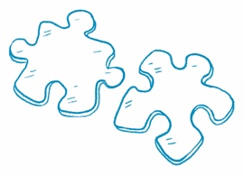
How Do They Compare?
Compare Information Find two news articles about
similar topics. Read each article and answer the questions.
Article 1 Title  Who Was Emmett Chappelle? | Article 2 Title  Syncing Fireflies
What is the main idea?  Emmett Chappelle was a scientist and inventor who helped others. | What is the main idea?  Some types of fireflies light up in unison.
What are the key details?  Chappelle went to an all-Black high school. He used bioluminescence to detect bacteria. He invented a way for astronauts to get oxygen. He helped minority high school and college students. | What are the key details?  Synchronous fireflies are rare in the United States. The flashing pattern of the fireflies is a mating display. The light is caused by a chemical reaction near the abdomen of the firefly.
What is the same about both articles?
Both articles discuss organisms that produce light.

What Do You Think?
Article Title The Economy and the Stock Market

Answer the question at the end of the article.
Draw or write.
The stock market can be doing well even though the economy is doing poorly. I think it is more important for the economy to be doing well because then most people have jobs and can meet their needs.

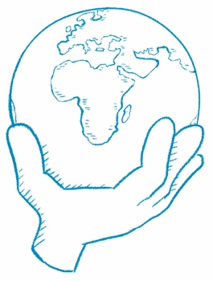
What Can You Do?
Article Title Happy Earth Day!

Answer the question at the end of the article.
Draw or write.
I can replace regular light bulbs with light bulbs that use much less energy (CFL). I can eat more plants and less meat. I can recycle. I can buy things with less packaging.

