What’s the Big Idea?
Main Idea What is this article mostly about?
Write the main idea. Then write three details that support the main idea.
Article Title

Main Idea

Detail
Detail
Detail

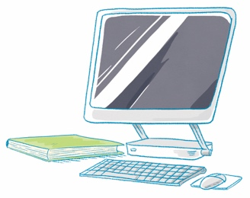
And Then What Happened?
Sequence Think about events that happened in the article. Write the events in the order they happened.
Article Title

First

Next

Then

Last

What Happened? Why?
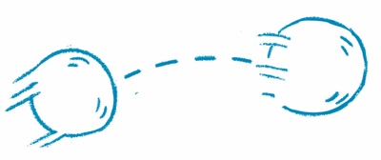
Cause and Effect What happened in this article? Why did it happen? A cause is the reason why something happened. An effect is the result of what happened.
Article Title

Find two cause-and-effect relationships in the text.
Cause
Effect

Cause
Effect

Write a short summary of the text.

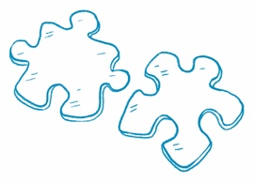
How Do They Compare?
Compare Information Find two news articles about
similar topics. Read each article and answer the questions.
Article 1 Title | Article 2 Title
What is the main idea? | What is the main idea?
What are the key details? | What are the key details?
What is the same about both articles?

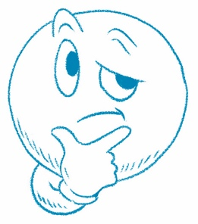
What Do You Think?
Article Title

Answer the question at the end of the article.
Draw or write.

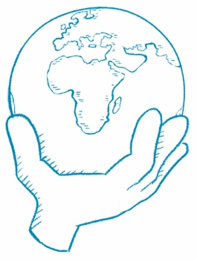
What Can You Do?
Article Title

Answer the question at the end of the article.
Draw or write.

